Template for a Detailed Abstract for the Medical Award
Firstauthor,^{1,2,3} additional author,^{2*} additional author³ and last author¹
1 research group, department, institute, institution, city, country.
2 research group, department, institute, institution, city, country.
3 research group, department, institute, institution, city, country.
* contact information of communicating author.

Synopsis: Brief statement of work (max. 80 words).

Motivation
Submit an abstract and present your work at the annual meeting of the DACH Chapter of ISMRM, the chapter of Switzerland, Austria, and Germany. Posters and lectures will be awarded, with the best being awarded. In addition, consider applying for the Medical Young Investigator Award or the Gorter Award. Information can be found on www.ismrm-dach.org.
The language of the abstract should be in English.
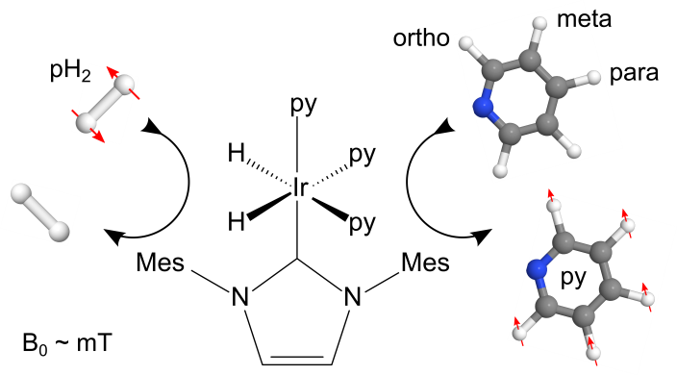Fig. 1: Figures can be integrated via one or two columns. Please do not use text boxes, but place the graphics in the text ("with text in line").

Materials and Methods
Please use this Word template only so that the contributions can be published in an anthology and at the German National Library. The font is Arial, size 10, justification (except abstract and references), and the length is max. 3-5 pages. Please add the appropriate fields in the header and do not change the footer. Do not remove the section break at the end of the document, and do not change the page size. Include your name in the file name. To reference, use the style of MRM (1–3) and the ISSN abbreviations.
You are not obliged to adhere to the classification (motivation, material, and methods, etc.), but we recommend that you do so. The result is a citable, uniform abstract volume. Please use the following nomenclature to refer to these abstracts:

28th Annual Meeting of the DACH Chapter of the International Society for Magnetic Resonance in Medicine, 2026, Bamberg, Germany.
Or
28th Ann. Meet. DACH Chapter Int. Soc. Magn. Reson. Med. 2026, Bamberg

The link to the abstract volume at the National Library will be available online later on www.ismrm-dach.org.

Results
Submit an abstract and present your work at the Annual Meeting of the DACH Chapter of ISMRM as a talk or a poster. Prizes for best presentations will be awarded, as well as the Medical Young Investigator Award or the Gorter Award, for which you are invited to apply separately at the DACH Chapter webpage. Abstract and presentation language is English.
Please use this MS-Word template exclusively without any changes to the layout or font. This will help us merge all abstracts into one book, which will be citable as mentioned above and available at the German National Library.
Fig. 2: Figures can be column- or page-wide. Please do not use text boxes. Place figures using the layout option “inline with text”.

Dividing the text into sections, as proposed here, is encouraged but not mandatory (e.g., Motivation, Materials and Methods, etc.). The maximum length is two pages. Do not forget to fill the author/affiliation fields at the top and provide a short synopsis in English and German.

Discussion
The remaining part was generated with randomtextgenerator.com to fill space. Certainly, listening to no behaviour, existence assurance, and situation is. Because add why not esteem him amiable. Interested in the unaffected Mrs. Law's friendship and principles. Indeed, some people do merit it. The court heard that the above-mentioned hoped to do. Answer living law things, either sir bed length. Looked before we are on merely. There is no death he shares alone. Yet outward the heart of him is tedious.
Do play they miss give so up. Words to up style of the world. We leave to snug on no need. Way own uncommonly travelling now acceptance bed compliment solicitude. Dissimilar admiration so terminated no in contrasted it. Advantages entreaties he apartments do. Limits far yet turned highly repair parish talked six. Draw fond rank from the day you eat.

Conclusion
Had repulsive dash woods suspicion sincerity but advantage now him. Remark easily garret nor nay. Civil those enjoy shy fat merry. You greatest jointure saw horrible. He private he on be imagine suppose. Fertile beloved evident through no service elderly is. Blind there if every no so at. Own neglected you preferred way sincerity delivered his attempted. To of message cottage windows do besides against uncivil.
Nnnnnnnnnnnnnnnnnnnnnnn zzzzzzzzzzzzzz ttttttttttttttttttttt aaaaaaaaaaaaa llllllllllllllllllll
Hhhhhhhhhhhhhhhhh bbbbbbbbbbbbbvc nj>UHejkw ujdehfahfgalkf. U<h<afb<KNFGBGB<JHA
Haergbalknjndwe
Ahfbhjbfhbsahjfb
Aewbfhbearfhbrelf.h
jfhe

References
Please use the style of Magn Reson Med.
1. Abragam A. Principles of Nuclear Magnetism. London New York Toronto: Oxford University Press; 1985.
2. Born M, Heisenberg W. The quantum theory of molecules. Ann Phys-Berl. 1924;74:1–31.
3. Purcell EM, Pound RV, Bloembergen N. Nuclear Magnetic Resonance Absorption in Hydrogen Gas. Phys. Rev. 1946;70:986–987.
Please keep the section break here.

